8.pielikums
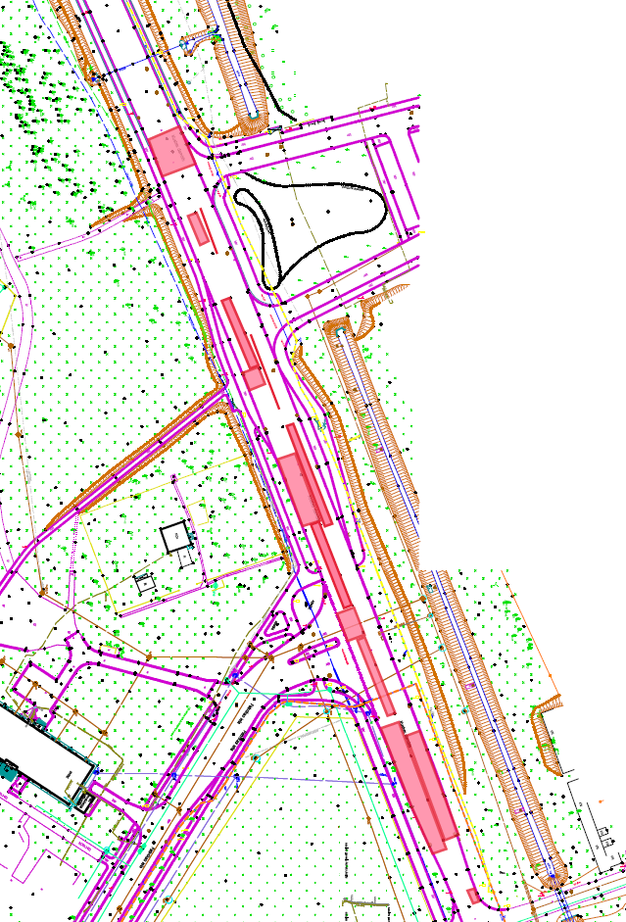
Atklātā iepirkuma nolikumam, identifikācijas Nr. VBOP 2024/48
1. 6,20m x 10,70m

1.šuve-15,00m 10,70m
2.šuve-3,00m

3.šuve –28,00m

10,70m

4. 8,50m x 1,50m
2. 8,00m x 1,50m
6. 34,00m x 1,50m

7. 1,00m x 2,00m
3. 17,50m x 1,50m
8. 34,00m x 1,50m

5 14,00m x 3,50m
10. 9,00m x 4,50m

11. 27,00m x 1,00m

4.šuve- 50,00m
9. 18,50m x 3,50m
5.šuve- 13,50m
12. 33,00m x 3,60m

13. 9,25m x 3,60m
6.šuve- 26,00m

7.šuve- 5,00m
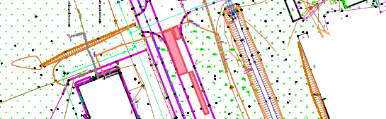
14. 10,00m x 3,30m
16. 5,00m x 1,00m
15. 8,00m x 1,80m

17. 14,00m x 3,60m
18. 14,60m x 1,90m

19. 14,30m x 1,70m
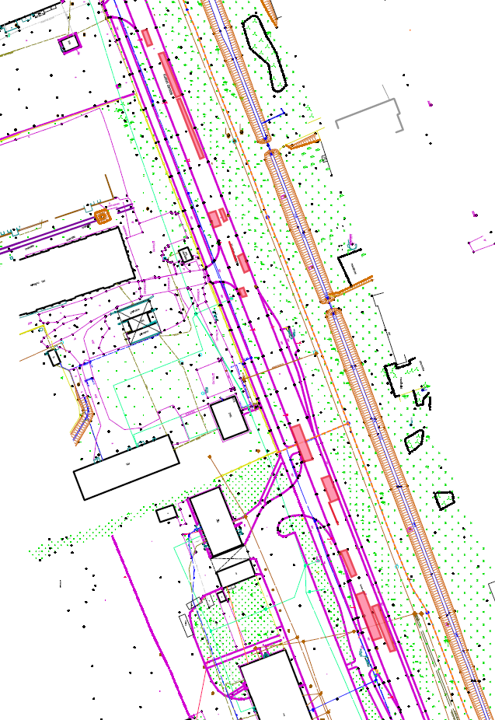

22. 8,00m x 3,60m
28. 10,00m x 3,30m
9.šuve 6,00m
30. 16,30m x 3,60m
29. 16,00m x 1,00m
27. 17,00m x 3,30m
23. 6,00m x 1,00m
25. 2,00m x 1,00m
21. 7,00m x 1,00m
8.šuve 7,00m

20. 3,30m x 14,50m

26. 15,50m x 3,50m
24. 1,50m x 9,50m

10. šuve 7,00m

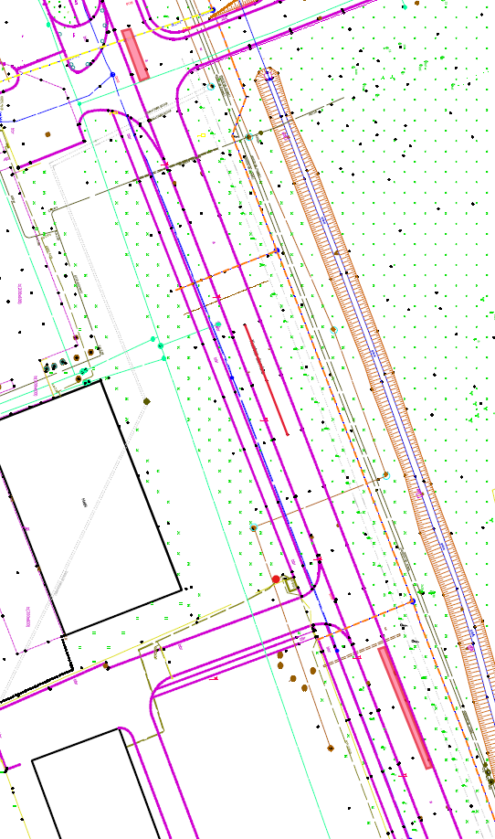
11. šuve 20,00m

13. šuve 8,00m
12. šuve 9,00m
31. 16,00m x 1,00m

14. šuve 3,00m

15. šuve 2,00m
16.šuve- 12,00m

17. šuve 5,00m

32. 0,50m x 0,50m

33. 28,00m x 1,00m

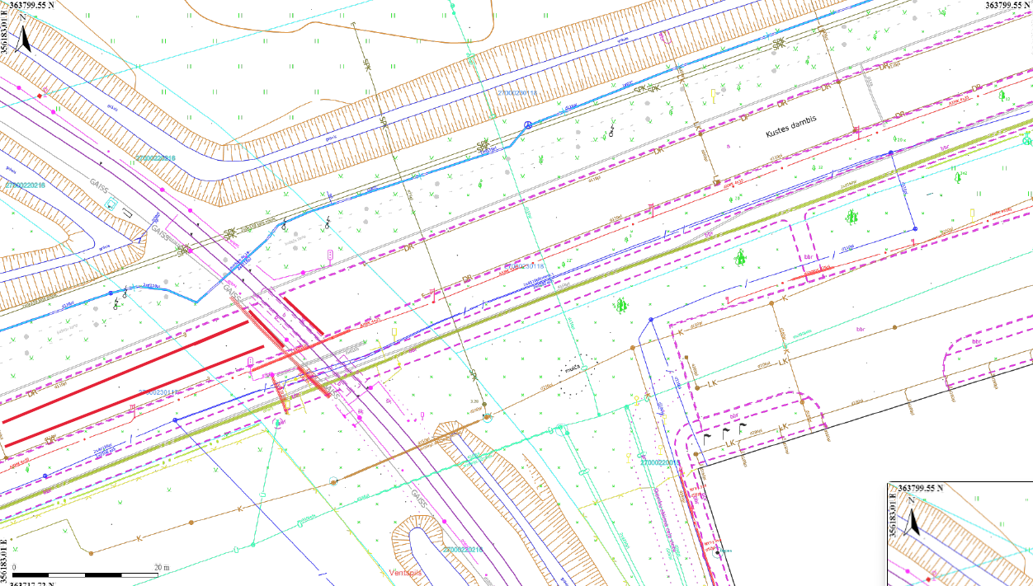
20. šuve 8,00m
19. šuve 8,00m
18. šuve 20,00m

21. šuve 50,00m

22. šuve 3,20m

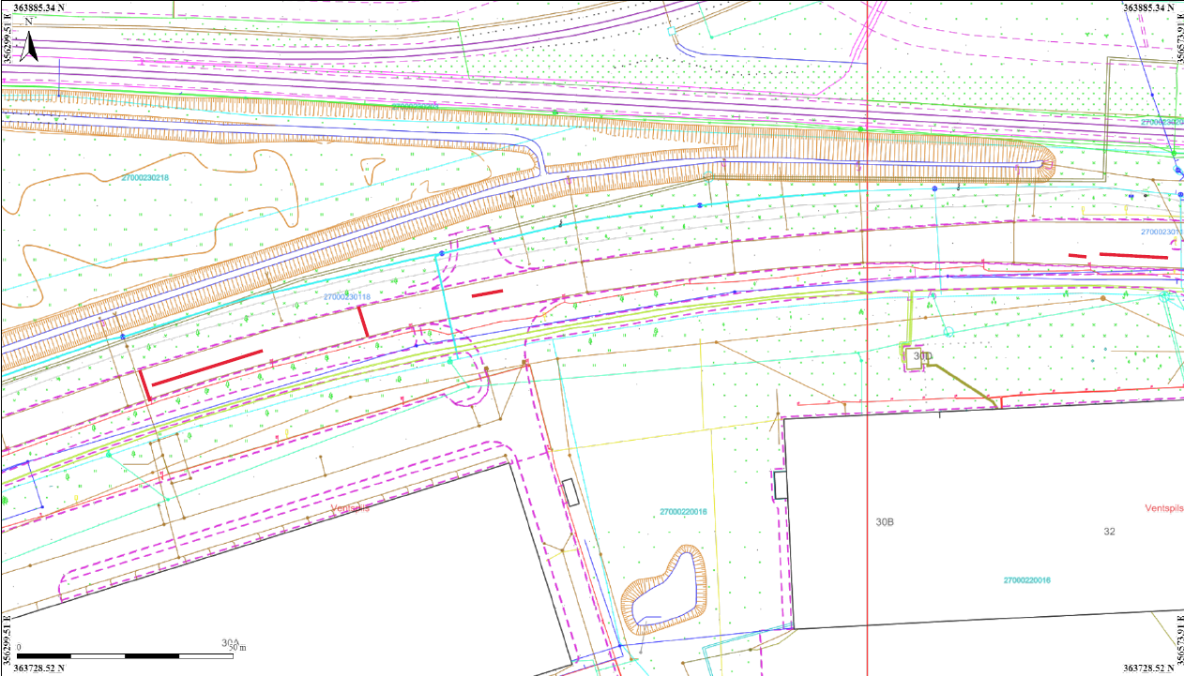
23. šuve 7,70m

24. šuve 3,00m

35. 10,00m x 1,00m

34. 4,40m x 2,00m

36. 9,50m x 3,50m
37. 14,10m x 1,00m

38. 3,60m x 4,20m
25. šuve 3,00m

26. šuve 3,00m

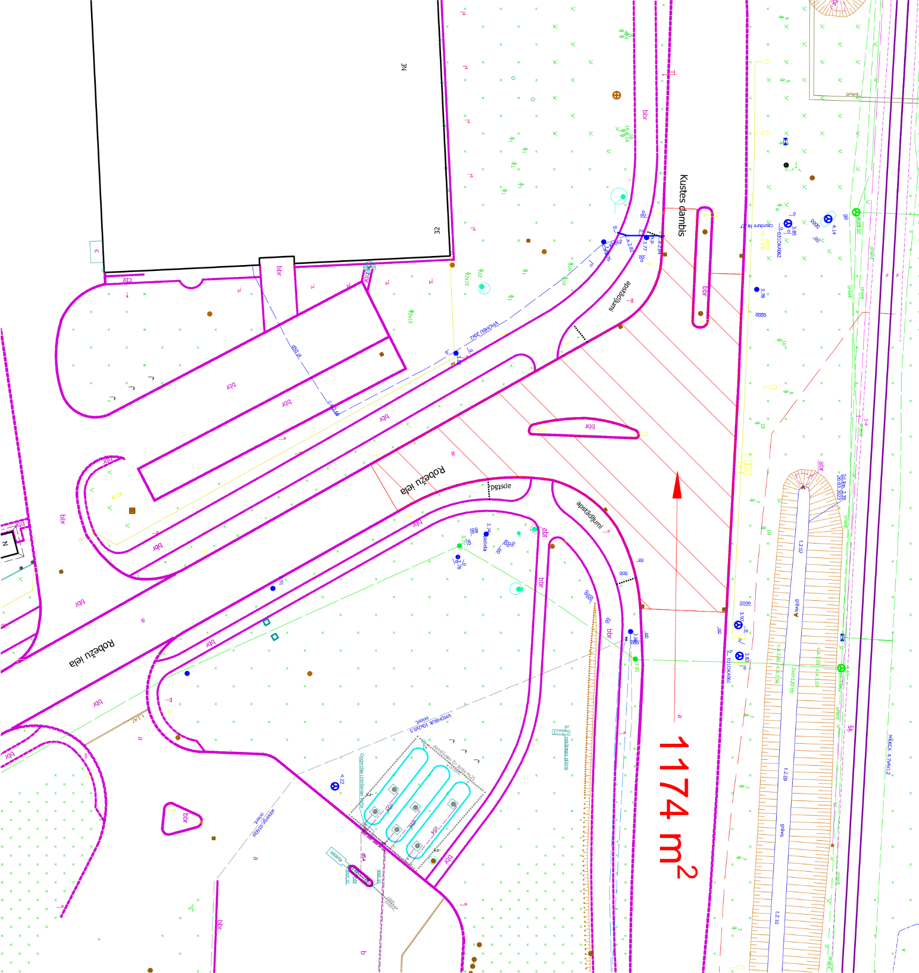
39. 1174m²

27. šuve 4,00m
40. 13,00m x 1,00m
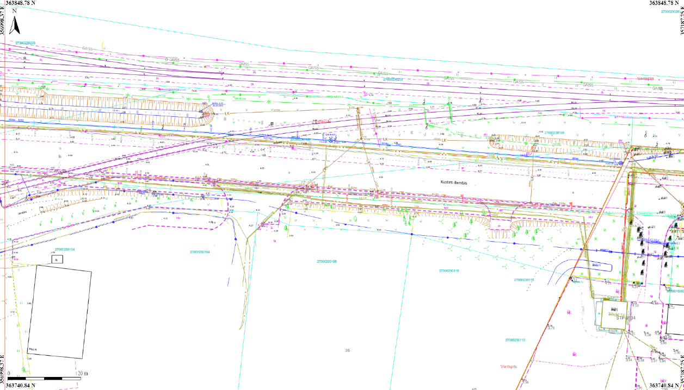
29. šuve 7,50m
28. šuve 45,00m
44. 3,00m x 1,00m
42. 31,64m²
43. 56,60m²
41. 204,47m²

