9.pielikums Atklātā iepirkuma nolikumam, identifikācijas Nr. VBOP 2024/48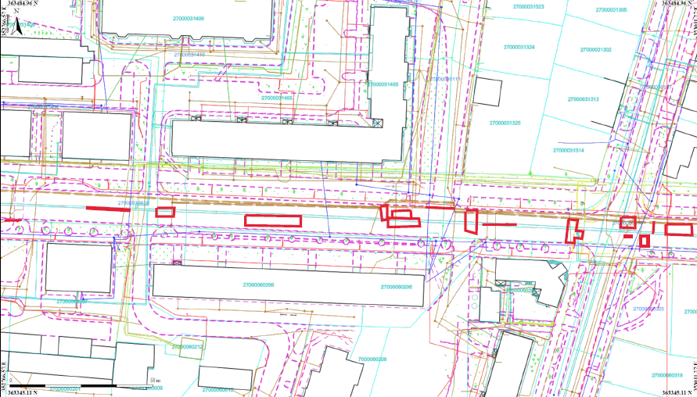
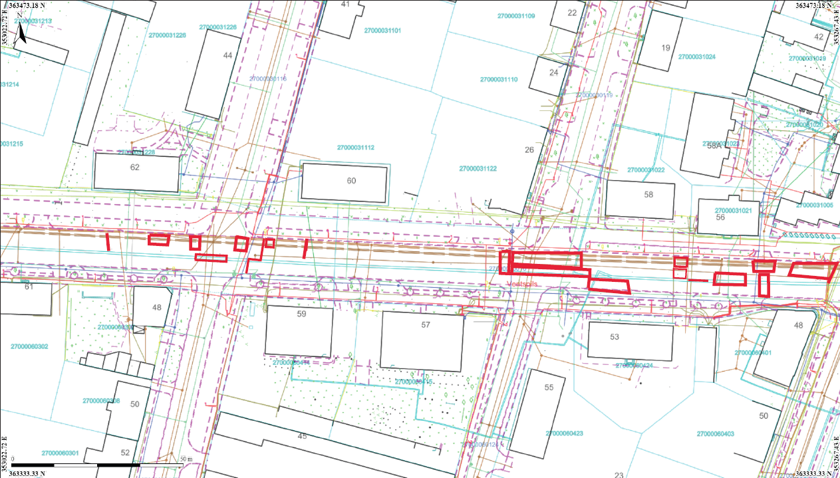
5. 6,30m x 2,10m
3. 1,80m x 0,70m
8. 2,4m x 0,50m
2. 2,00m x 9,00m
6. šuve 10,40m

6. 8,10m x 1,00m
1. 3,80m x 1,00m
3. šuve 10,20m
2. šuve 19,00m
7. šuve 7,00m
8.šuve 8,80m
5. šuve 1,00m
7. 31,06m²
4. šuve 5,00m
4. 4,70m x 1,20 m
1. šuve 3,00m
9. 2,00m x 6,50m
10. 2,40m x 1,00m
11. 2,90m x 1,00m
90
12. 1,00m x 1,50m
13. šuve 3,00m 19,00m
12. šuve 2,00m
15. 8,20m x 2,70m
13. 3,40m x 1,00m
14. 1,70m x 15,00m
17. 1,70m x 0,80m
14. šuve 4,00m
19. 3,10m x 1,30m
16. 0,80m x 1,80m
20. 3,70m x 1,10m
21. 3,00m x 8,40m
22. 4,50m x 1,50m
18. 2,00m x 1,00m
10.šuve 7,50m
11. šuve 7,50m
9. šuve 2,00m
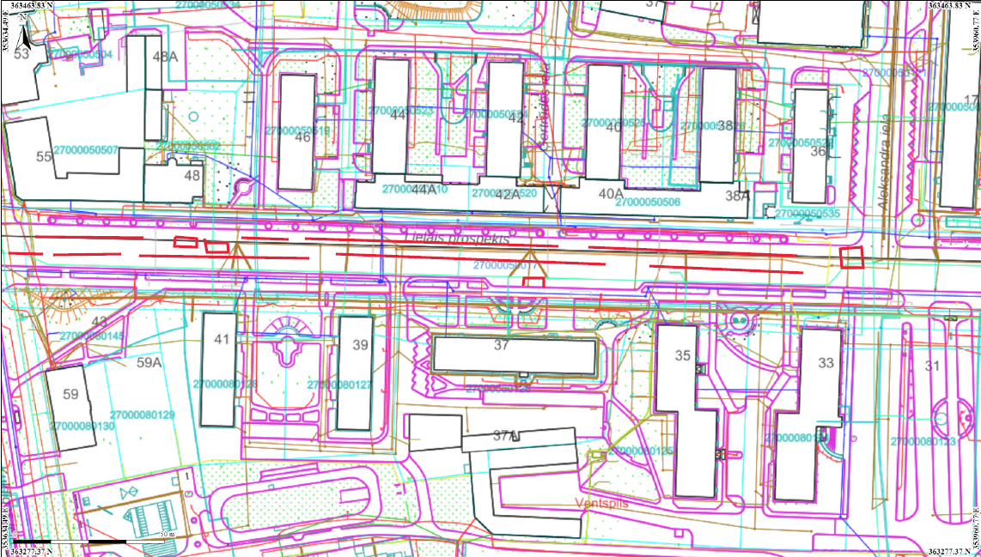
25. 6,80m x 3,00m
16.šuve 300,00m
23. 3,50m x 1,00m
24. 4,00m x 0,80m
15.šuve 6,30m 1,00m
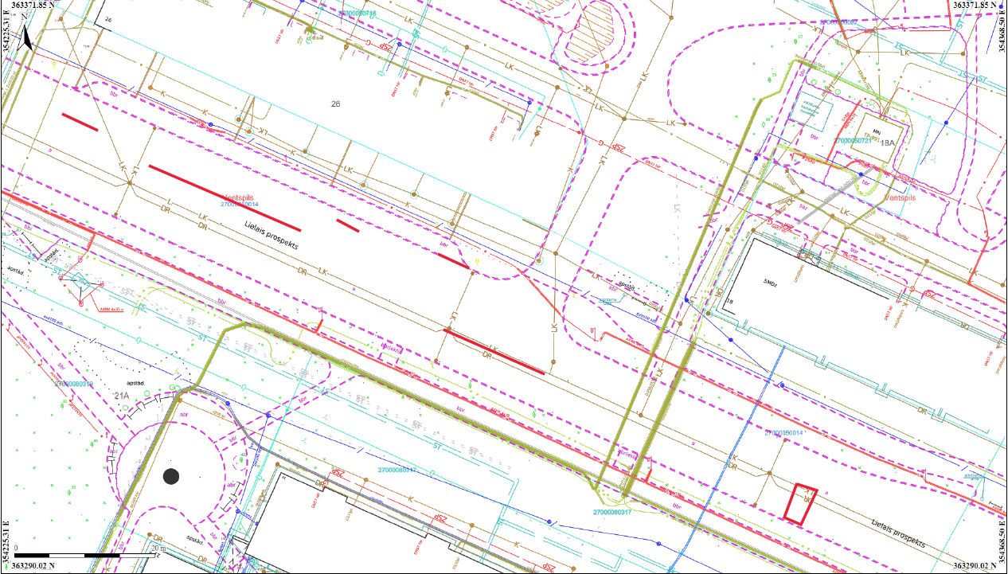
26. 7,00m x 1,00m 11,00m 1,00m
21.šuve 11,00m
19.šuve 4,00m
20.šuve 2,80m
17.šuve 3,00m
18.šuve 30,00m
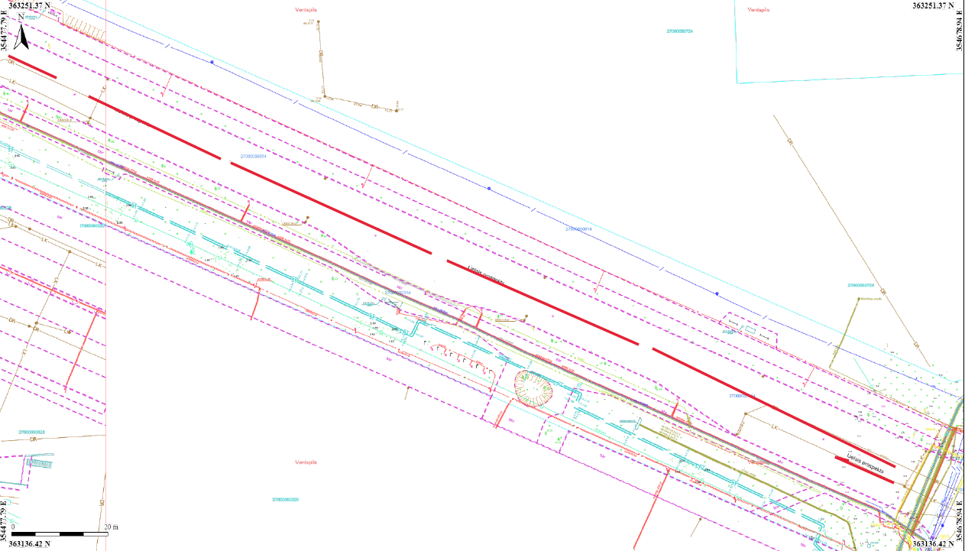
23.šuve 8,00m 1,00m 11,00m 1,00m
22.šuve 100,00m 1,00m 11,00m 1,00m

